Probability and Statistics Programming Project #2
소속 : 컴퓨터학부 학번 : 2021113411 이름 : 표수현 일시 : 2024/12/11
1. Central Limit Theorem Simulation Experimental
1.1. A distribution of the proportion $p$ of Binomial distribution
Let a random variable $X\sim B\left(n,p\right)$, where $n$ and $p$ are the number of Bernoulli trials and the proportion of success, respectively. In this case, an unbiased point estimate $\hat{p}$ of $p$ can be defined as $\hat{p}=\frac{X}{n}$, and $\hat{p}\sim N\left(p,\frac{p\left(1-p\right)}{n}\right)$ from the following equations.
$$E\left(\hat{p}\right)=E\left(\frac{X}{n}\right)=\frac{E\left(X\right)}{n}=\frac{np}{n}=p, Var\left(\hat{p}\right)=Var\left(\frac{X}{n}\right)=\frac{Var\left(X\right)}{n^{2}}=\frac{np\left(1-p\right)}{n^{2}}=\frac{p\left(1-p\right)}{n}$$
In order to investigate a distribution of proportion of $\hat{p}$, we assume that the number of Bernoulli trials $n$ is 30 and the proportion of success $p$ is 0.5, that is, $X\sim B\left(30,\frac{1}{2}\right)$.
For your experimental, you need to choose 30 random samples per each iteration for 500 iterations, that is, you can obtain the following data:
$${\hat{p}}_{i}=\frac{\sum_{j=1}^{30}{X_{j}}}{30}, for i=1,…,500$$
Q1.1.1. (10pt) Draw a histogram of ${\hat{p}}_{i}$ and a normal distribution $N\left(p,\frac{p\left(1-p\right)}{n}\right)=N\left(\frac{1}{2},\frac{1}{120}\right)$. In the below figure, $N\left(0.5,sqrt\left(1/120\right)\right)$ is a function to draw a normal distribution in MATLAB($N\left(μ,σ\right)$).
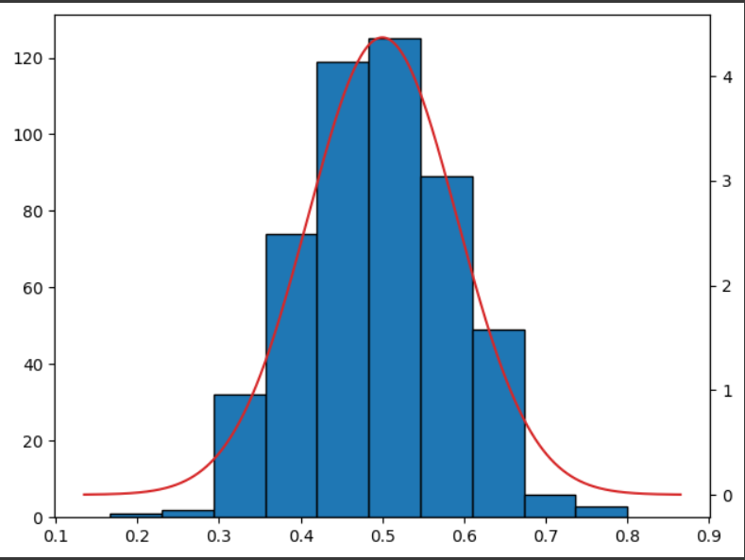
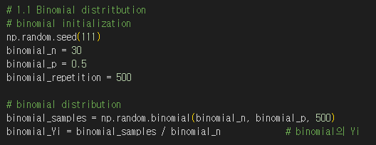
1.2. A distribution of the mean of an exponential distribution
Similar to 1.1, let a random variable $X\sim Exp\left(λ\right), λ=0.1$ and $Y_{i}=\frac{\sum_{j=1}^{30}{X_{j}}}{30}, for i=1,..,500$.
Q1.2.1. (5pt) Calculate $E\left(Y\right)$ and $Var\left(Y\right)$.
$$E\left(Y\right)=\frac{1}{λ}=10, Var\left(Y\right)=\frac{1}{nλ^{2}}= \frac{10}{3}$$
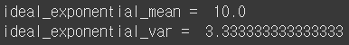
Q1.2.2. (10pt) Draw a histogram of $Y_{i}$ and a normal distribution $N\left(E\left(Y\right),Var\left(Y\right)\right)$.
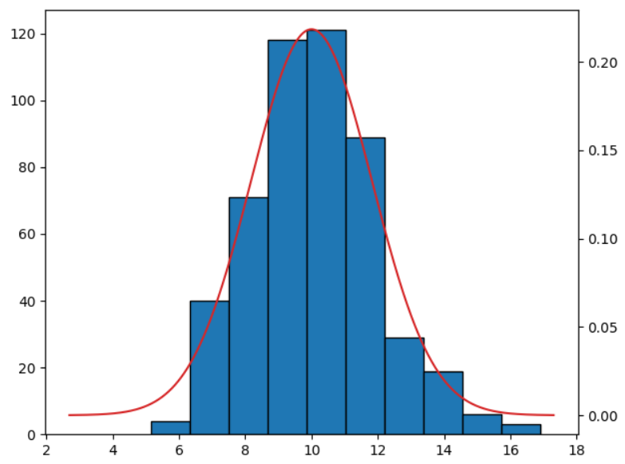
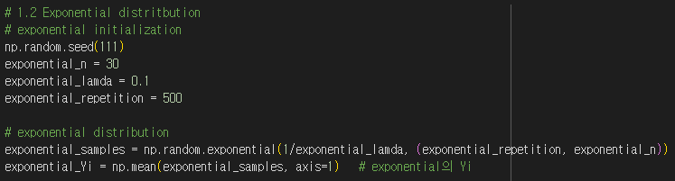

1.3. A distribution of the mean of a Poisson distribution
Similar to 1.1, let a random variable $X\sim P\left(λ\right), λ=10$ and $Y_{i}=\frac{\sum_{j=1}^{30}{X_{j}}}{30}, for i=1,..,500$.
Q1.3.1. (5pt) Calculate $E\left(Y\right)$ and $Var\left(Y\right)$.
$$E\left(Y\right)=λ=10, Var\left(Y\right)=\frac{λ}{n}= \frac{1}{3}$$

Q1.3.2. (10pt) Draw a histogram of $Y_{i}$ and a normal distribution $N\left(E\left(Y\right),Var\left(Y\right)\right)$.
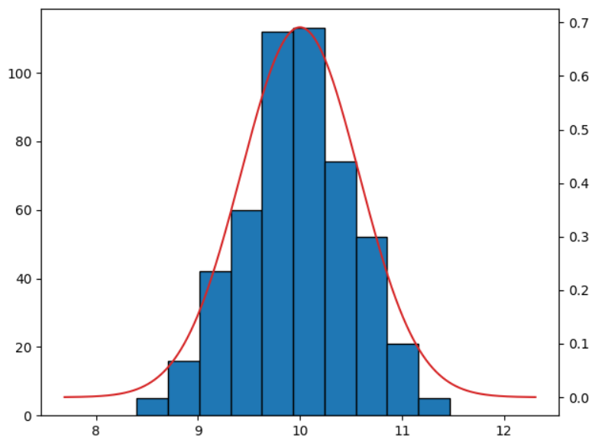
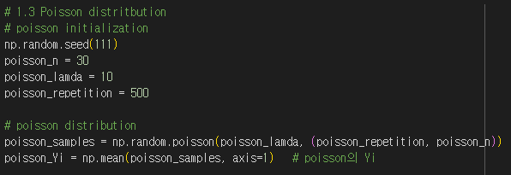

2. A distribution of the variance of a normal distribution
Let a random variable $X\sim N\left(10,3\right)$ and $Y_{i}=\frac{\sum_{j=1}^{30}{X_{j}}}{30}$, $S_{i}^{2}=\frac{\sum_{j=1}^{30}{{\left(X_{j}-Y_{i}\right)}^{2}}}{29}$.
Q2.1. (10pt) Draw a histogram of $S_{i}^{2}$ and verify the histogram to $χ_{29}^{2}$ distribution.
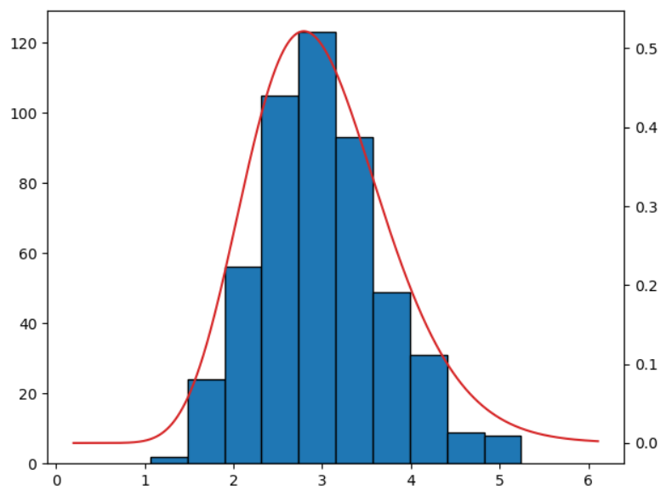
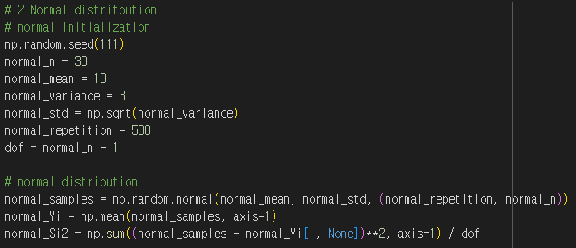

3. A distribution of a student-t distribution.
Let a random variable $X\sim N\left(10,3\right)$ and $Y_{i}=\frac{\sum_{j=1}^{30}{X_{j}}}{30}$, $S_{i}^{2}=\frac{\sum_{j=1}^{30}{{\left(X_{j}-Y_{i}\right)}^{2}}}{29}$. For each iteration($i$), calculate $t$-statistic as following:
$$t_{i}=\frac{\sqrt{30}\left(Y_{i}-μ\right)}{S_{i}}\sim t_{29}$$
, where $μ$ is the mean of population, and $t_{29}$ is a t-distribution with 29 DOF.
Q3.1. (10pt) Draw a histogram of $t_{i}$ and a student-t distribution with 29 DOF.
